**CASE STUDY: CUSTOMER SUPPORTING SYSTEM (Online Book Store)**

1. AIM: Develop high level sequence diagram for each usecase



**b) Aim:** Identify MVC Classes

**View Model Controller**

ICustomer Book Order Form

Ilogin Mode of payment

Ilogout

IAddress

ISeller

**c) Aim:** Develop Communication Diagram

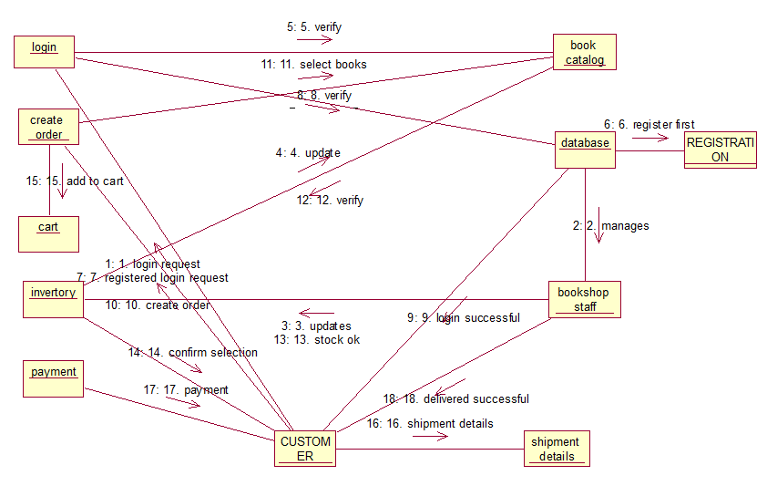

**d) Aim:** GRASP Patterns and their Responsibilities

Specified by

Address

Customer

Customer specified by address and also responsibility assigned for address i.e., information expert, low coupling patterns.

Updates

Book

Seller

Seller updates Book and also responsibility assigned for Books i.e., high cohesion, information expert, patterns.

Payment

Order Form

Mode of payment

Order form payments mode of payment and also responsibility assigned for Mode of payment i.e., creator, information expert, patterns.

**e)** **AIM:** Developing three-layer package diagram for Library Management System.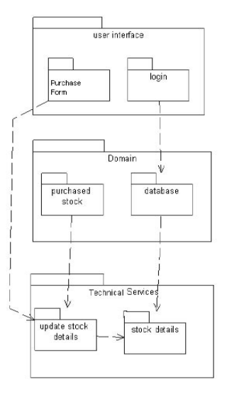

**Result:** The Design was successfully completed.